Linux exercise 10-Process management
- Run command ps aux | less and find descriptions for column titles used in output.
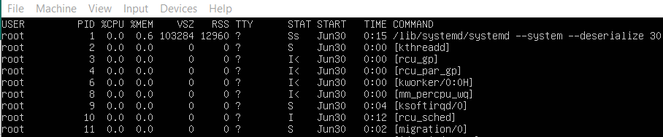
- USER: the user running the process
- PID: the process ID
- %CPU: Percentage of CPU usage since the last screen update
- %MEM: percentage of RES memory usage since the last screen update
- VSZ: Is the Virtual Memory Size
- RSS: Resident Set Size and is used to show how much memory is allocated to the process
- TTY:The terminal.
- STAT: Shows you the current status of the process.
- START: Date the process started
- TIME+: total CPU time used since the process started
- COMMAND: the command, as described above

- What is the default delay for top commands screen updates? Change this update time to 0.5 seconds.
Default delay: 3 seconds
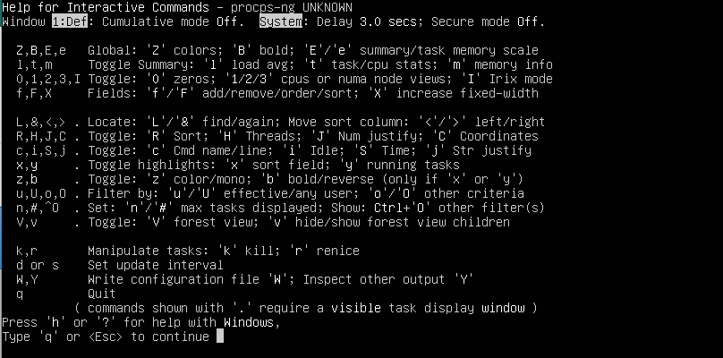
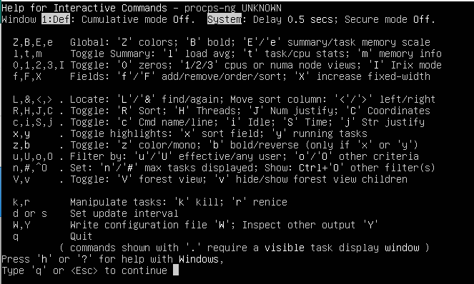
- Open another SSH connection to your Ubuntu (for example using Putty) and shutdown this connection using kill command (Tip: use PID of opened SSH connection).
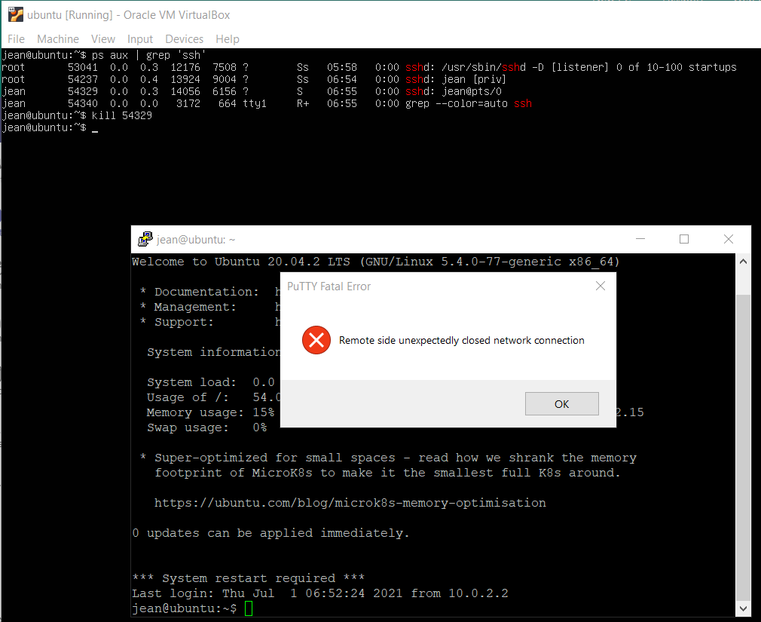
- Open another SSH connection again to your Ubuntu. Print the tree view of processes when SSH connection has been established. Now shutdown the second SSH connection and print the tree view again. How is SSH connection displayed in tree view on both cases (connection established and connection closed)?
In the first case there is a top level sshd and a pir of other sshds
In the second case there is only the top level sshd
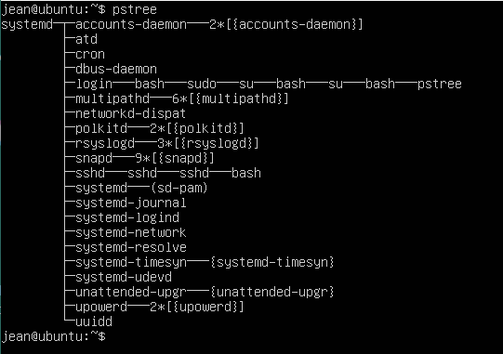
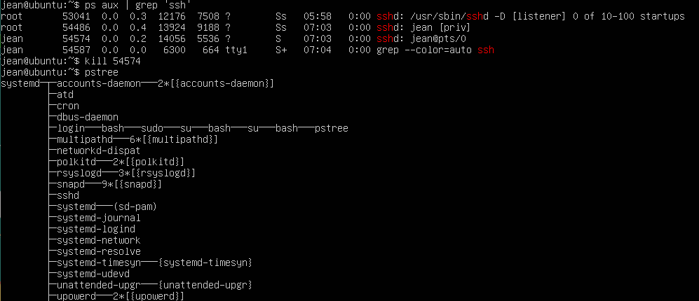

- Why is SSH displayed in tree view even when there is no SSH client connection open from Putty? Important: In VLE environment you will always have SSH client connection open!
I believe sshd we see after closing the connection is the main listener. It is probably there because we are using virtual machine

- How can you shutdown SSH connection through top program?
While top is running, type “k” and give the PID of the ssh connection you want to close.

